# ESE Tasks/Notes

**CompressionController**

ToF Sensor Address: 0x29

Touch Sensor Address: ??

**VentilationController**

DLC A Sensor Address: 0x29

DLC B Sensor Address: 0x2B

SDP Sensor Address: 0x25

**SmartHubController (Mainboard)**

Data from Compression and Ventilation Controller

**Compression:**

- Create reliable Arduino code (With user requirements in mind)

- Unit testing (ToF)

- Integration testing (Backbone)

- System testing (Manikin)

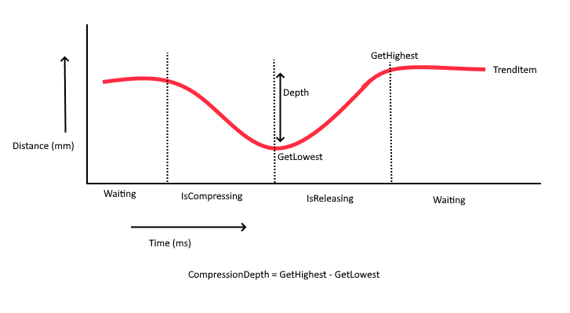

**Ventilation:**

- Design Ventilation system (Which sensors. Johan ordered new sensors)

- Create reliable Arduino code (With user requirements in mind)

- Unit testing (Ventilation sensors)

- Integration testing (Backbone)

- System testing (Manikin)

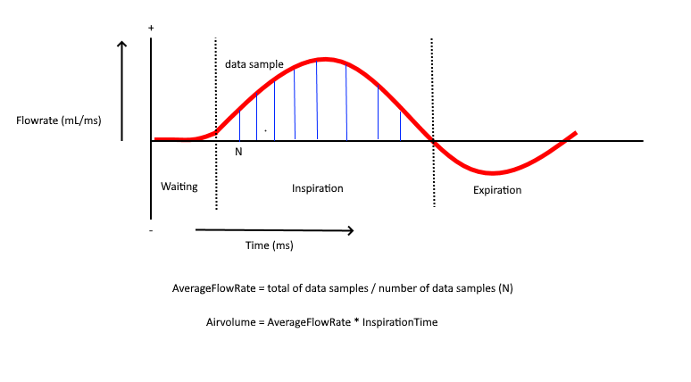

**Head-tilt**

- IMU sensor

**Implementing the RTOS**

- Get familiar with the given code

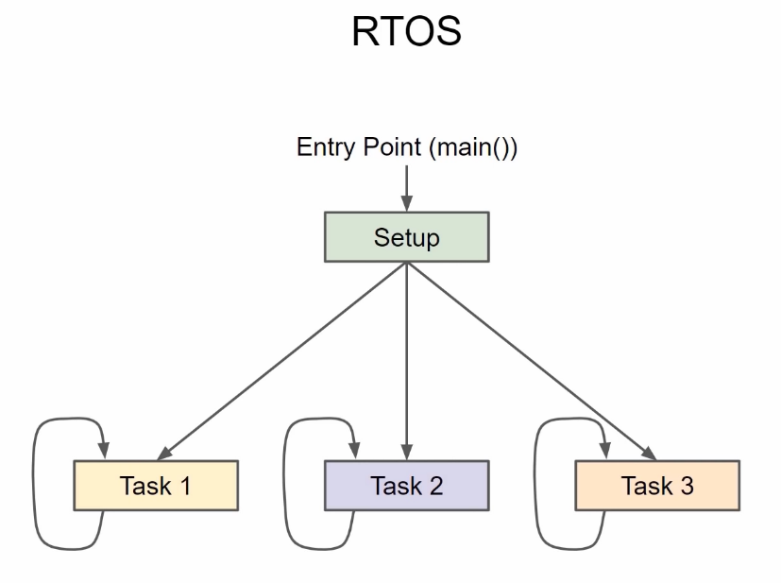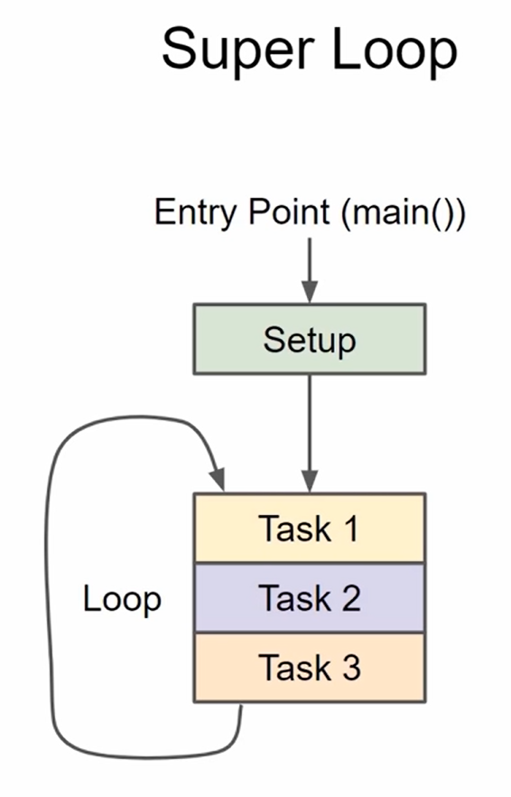

Normally, tasks are handled one by one. With RTOS you can perform tasks "simultaneously".

RTOS use a Tick timer for handling different tasks. By default 1 tick is 1 ms.

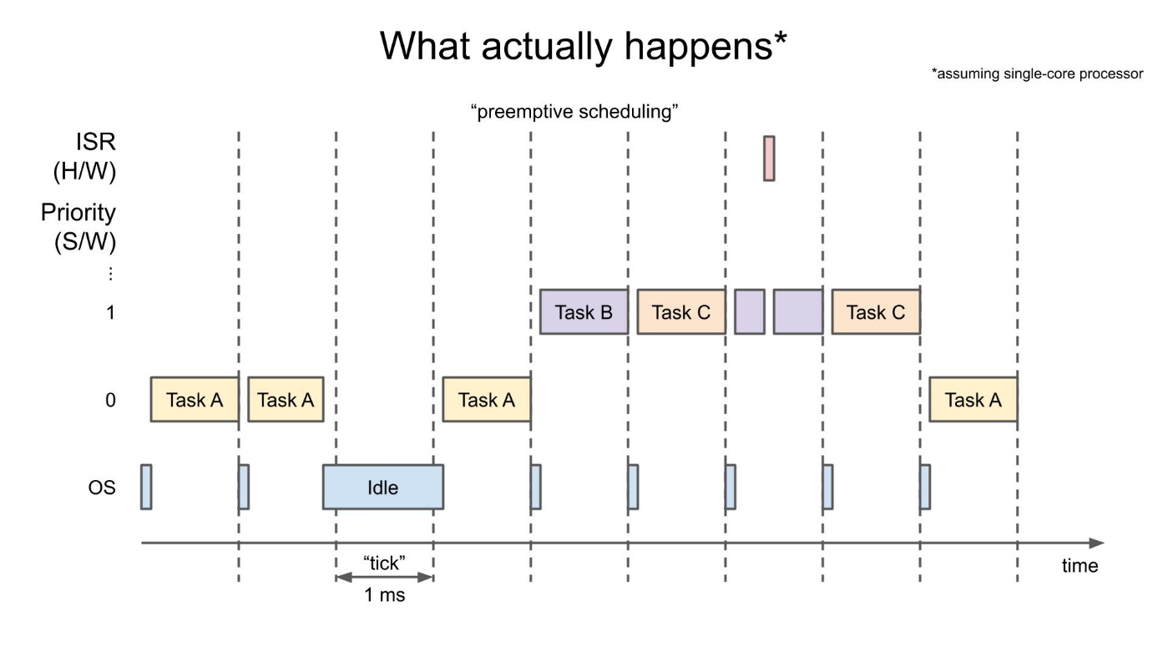

Questions integration RTOS meeting?

# Testing

# Information

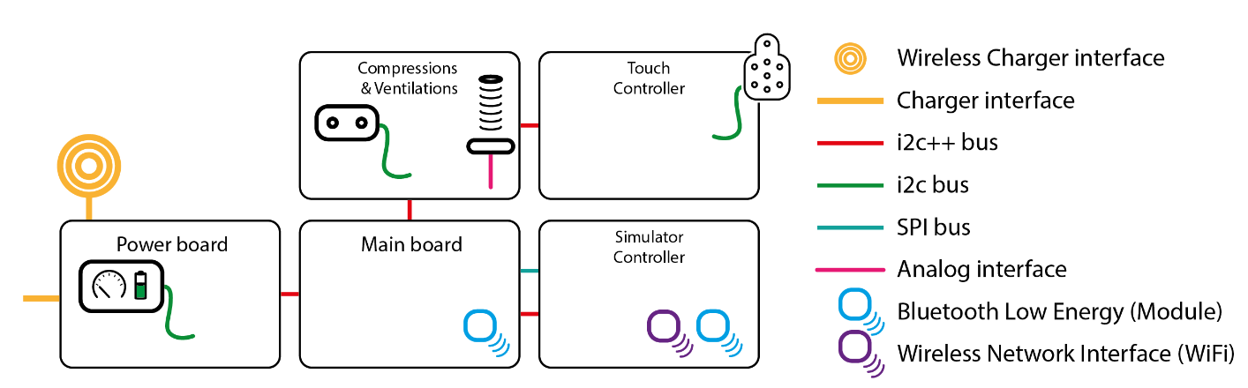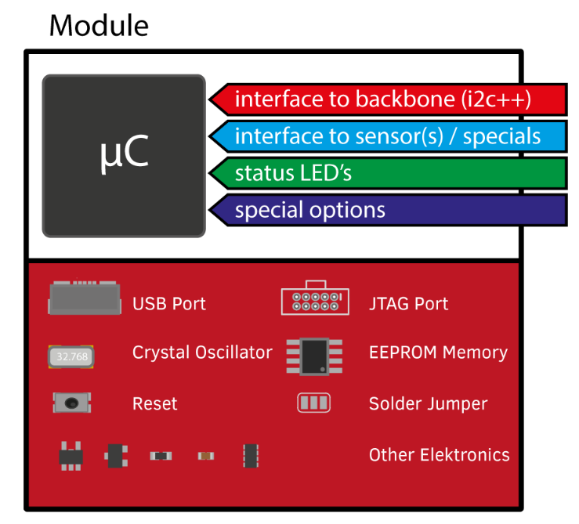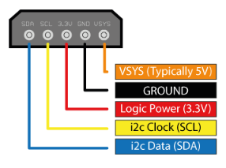

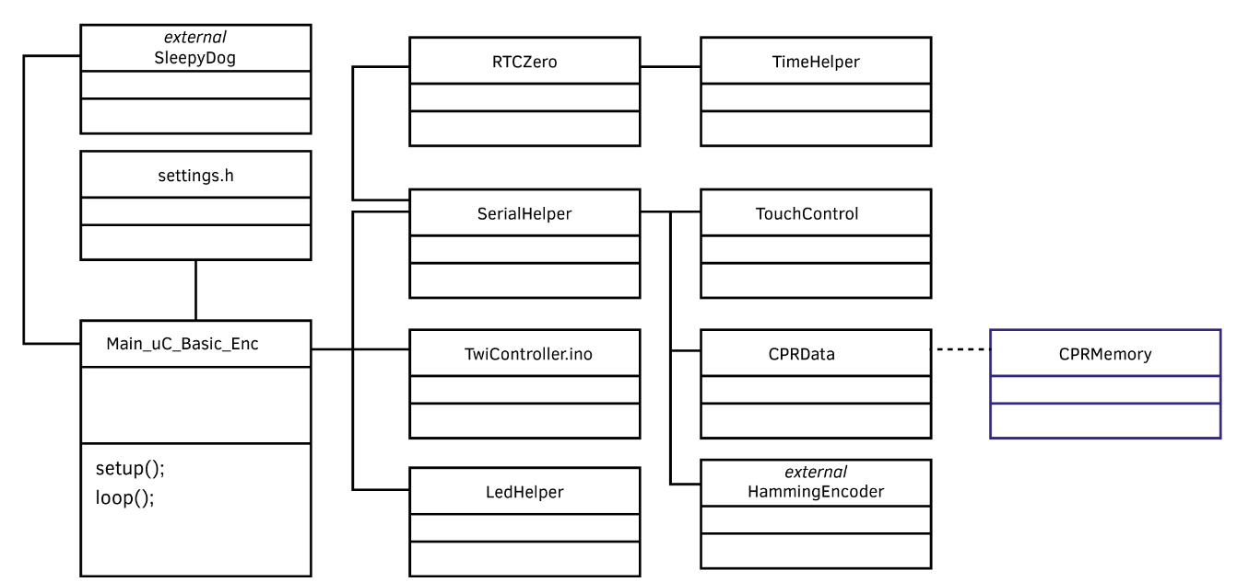**Mainboard**